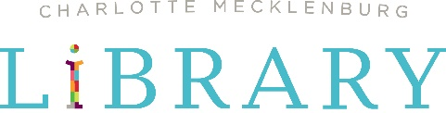

News Release

FOR IMMEDIATE RELEASE

PARTICIPATE IN COMMUNITY DISCUSSIONS CENTERED ON TOPICS OF
URBAN RENEWAL AND FINDING HOME DURING COMMUNITY READ 2022
Join authors Chrystal D. Giles, Pablo Cartaya, Anna Jean Mayhew and Ibi Zoboi in four free online events

Charlotte, NC – March 1, 2022 – Charlotte Mecklenburg Library will showcase featured authors in four free online events for Community Read 2022, with a focus on creating community dialogue around themes of gentrification, urban renewal and finding home. The first event is March 8 at 10a.m. with Chrystal D. Giles, author of Take Back the Block followed by a visit from Pablo Cartaya, author of The Epic Fail of Arturo Zamora on March 16 also at 10a.m. Students from Charlotte-Mecklenburg Schools will have the opportunity to ask questions of both Giles and Cartaya in a virtual panel discussion.
Anna Jean Mayhew, author of the signature title Tomorrow's Bread will visit on March 23 at 6p.m. and Ibi Zoboi, author of Pride: A Pride & Prejudice Remix will visit on March 30 also at 6p.m. These author events are online and consist of live discussions with Q&A sessions at the end. All events are free to the community, and information on how to sign up is located here. A recording of each event will be available for viewing afterwards on the Library’s YouTube page here.
Community Read 2022 is the Library’s monthlong program to have the community read (or listen) to books of current and relevant topics. Throughout March, the Library will host readings, book discussions and other programs for participants that bring the books’ themes to life. Adults are encouraged to read and discuss the main title, Tomorrow's Bread, by Anna Jean Mayhew, and the Library-selected companion titles for children and teens include: Windows by Julia Denos (children), The Blue House by Phoebe Wahl (children), The Epic Fail of Arturo Zamora by Pablo Cartaya (middle grade), Take Back the Block by Chrystal D. Giles (middle grade) and Pride by Ibi Aanu Zoboi (teen). More information and a full events schedule can be found at cmlibrary.org/community-read.
“Our vision as an accessible, welcoming and inclusive Library is to be the essential connector of a thriving community of readers, leaders and learners,” said Caitlin Moen, chief library services officer at Charlotte Mecklenburg Library. “To achieve that goal, we have to give members of the community a safe space to have their voices and diverse perspectives heard, to engage in challenging, sometimes-tough conversations and explore history, the present and the future together so that we can move forward with renewed optimism and hope for tomorrow. Community Read 2022 will allow us to do just that.”
All books for Community Read 2022 are available through the Library’s catalog in print, digital and audio formats. Community Read titles are also being distributed through Community Read partner organizations leading up to the events.
Community Read is presented with support from National Endowment for the Humanities and the Charlotte Mecklenburg Library Foundation.
To learn more about Community Read, visit cmlibrary.org/community-read.

About Charlotte Mecklenburg Library:
Charlotte Mecklenburg Library is one of America’s leading urban public libraries, serving a community of more than one million citizens in Mecklenburg County, North Carolina. Through 20 locations, targeted outreach and online resources, the Library delivers exceptional services and programs, with a mission to improve lives and build a stronger community. For more, visit cmlibrary.org.

###

Photo caption 1-4:

Celebrate Community Read 2022 with virtual visits from four of the signature authors: Chrystal D. Giles, Pablo Cartaya, Anna Jean Mayhew and Ibi Zoboi.

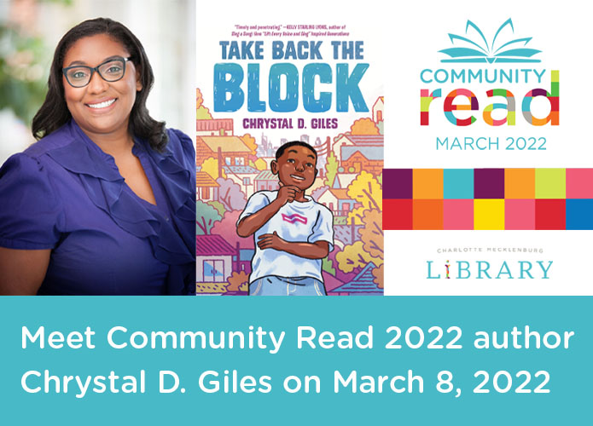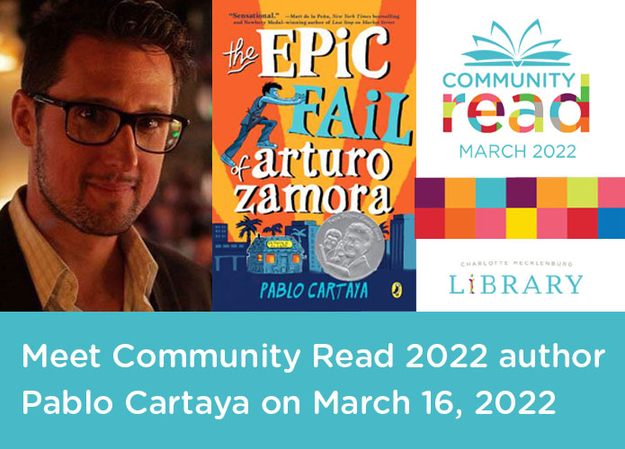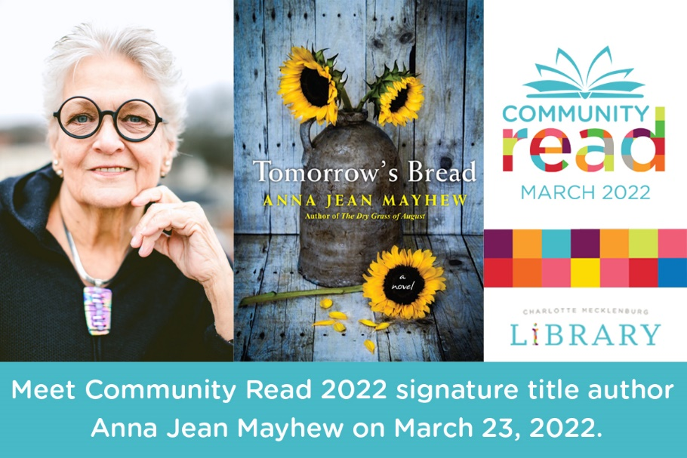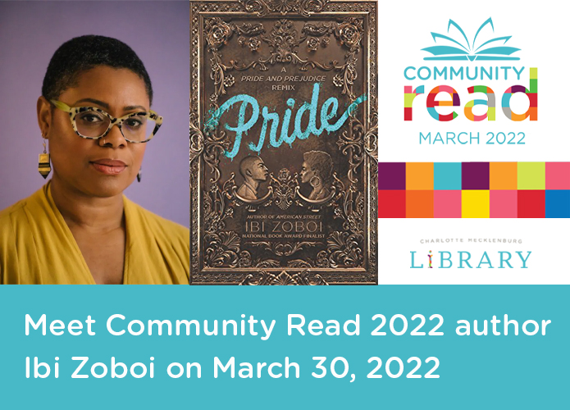

Media Contact:
Darrell Anderson
Marketing & Communications Specialist
Charlotte Mecklenburg Library
704-416-0701
danderson@cmlibrary.org

Media resources:
Charlotte Mecklenburg Library newsroom: cmlibrary.org/library-news

Social sharing:
Hashtags: #cmlibrary #communityread2022
Facebook: www.facebook.com/cmlibrary
Twitter: @cmlibrary www.twitter.com/cmlibrary
Instagram: www.instagram.com/cmlibrary
LinkedIn: www.linkedin.com/company/charlotte-mecklenburg-library

